PRESS SERVICES FOR EXHIBITORS

1. Use of press display units in the Press Centre (free of charge)

2. Registration of your press events (free of charge)

3. Your new products online at www.prolight-sound.com/exhibitorsearch
(free of charge – only as part of the obligatory Media Package)

4. Your press releases online at www.prolight-sound.com/exhibitorsearch (at extra cost)
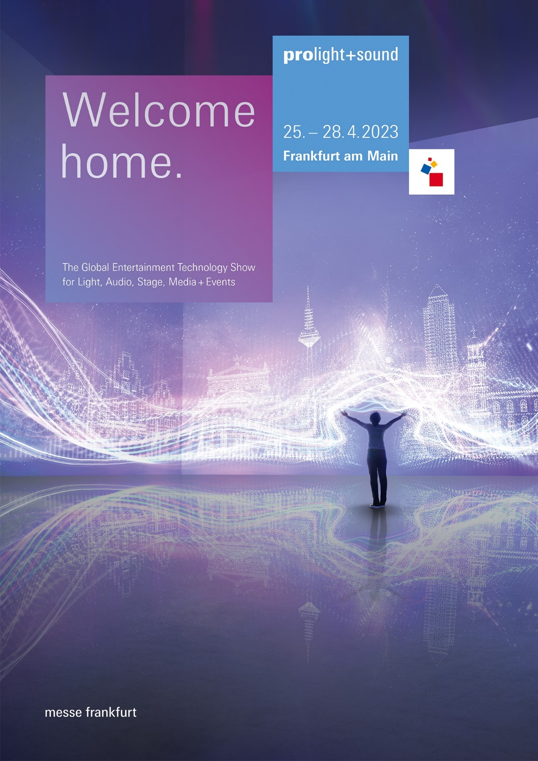

Delivery deadline: 15 April 2023

Contact: Ilona Schlesinger-Jakoby
Telephone: +49 69 7575-5229
Email: ilona.schlesinger-jakoby@messefrankfurt.com

Reservation of press display units in the Prolight + Sound 2023 Press Centre

This service is free of charge
The Press Centre is the meeting place of the international trade press during the fair and you can present your press kits and press releases there throughout Prolight + Sound 2023.
                - Brief texts are the best way to ensure the press takes notice of your company.
                - Your press releases should be available for the journalists in German and English.

                - Press photos must be suitable for reproduction and should be printable in digital form on a CD or USB thumb drive with a resolution of 300 dpi.

                - The press display units (31 x 10 x 31 cm) are suitable for A4 formats.

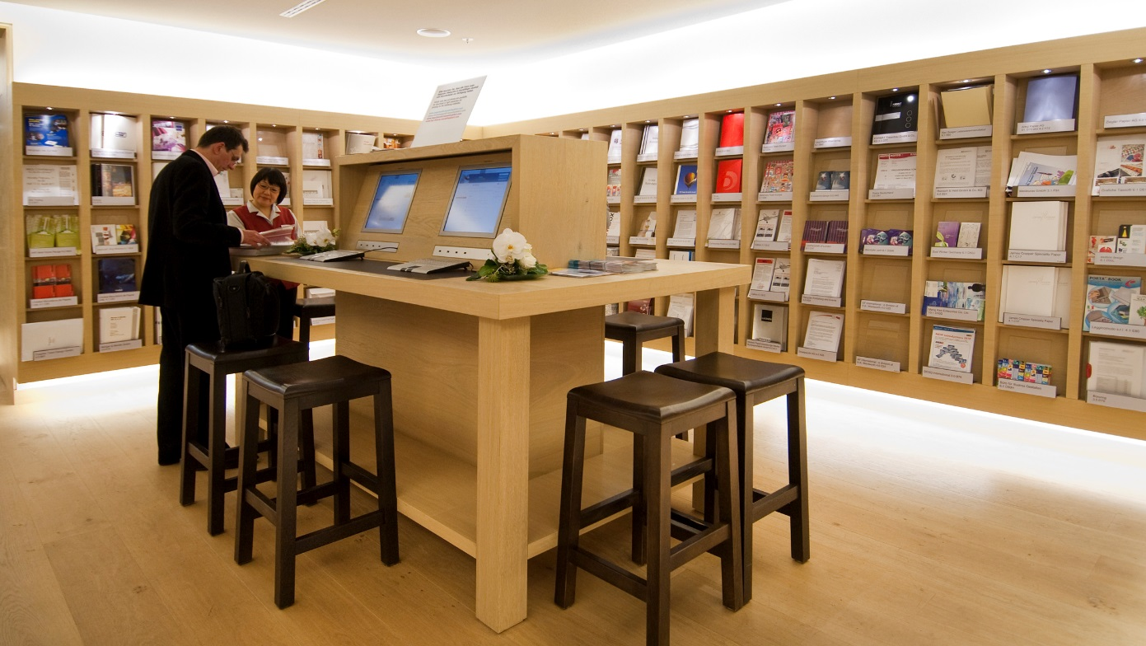

                - (Photo: press display units in the Press Centre, Torhaus, Level 4)

If you bring us your printed press material on the day before the fair begins, you need do no more. We will ensure that the press display units are checked regularly to ensure there is sufficient material in them, as well as store your material and replenish the units as necessary.
The press display unit will be labelled with your company name and thus be easy to find for journalists looking for information specifically about your company.
We recommend that you provide approx. 100 copies per press display unit.
REPLY Reservation of press display units:
(Also bookable over: https://serviceshop.messefrankfurt.com)

                - We hereby order for the presentation of press material during Prolight + Sound 2023:

 | Press display units in the Press Centre | Number of press display units: ..............  (max. 2)

Place, date Signature and company stamp

Company name (as per catalogue entry): ……............................................................................

-----------------------------------------------------------------------------------------------------------------------------

Contact person: ………………………………................................................................................

Telephone: ...................................................................................................................................

Email: ...........................................................................................................................................

Internet: http://...............................................................................................................................

Hall/aisle/stand no.: ......................................................................................................................

.
Deadline for receipt: 15 April 2023

Contact: Ilona Schlesinger-Jakoby
Telephone: +49 69 7575-5229
Email: ilona.schlesinger-jakoby@messefrankfurt.com

Registration of a press event at Prolight + Sound 2023
(Also bookable over: https://serviceshop.messefrankfurt.com)
This service is free of charge
This service is free of charge.

Do you want to hold an event for the press during Prolight + Sound 2023?
We coordinate the dates and times to avoid clashes.
We publish the details of your event in a list that we supply to journalists in printed form and via displays in our Press Centre. They are also published online at www.Prolight-Sound.com/press

Should you not want to hold the press event on your exhibition stand, we will be pleased to help you to reserve a suitable room. Please contact our colleagues from the room reservation, Viktor Zipp, Tel.: +49 69 7575 5778, email: viktor.zipp@messefrankfurt.com.

                - Please note:
                - All preparations – invitations to the press, holding, organising and financing the event – are your responsibility. However, we will be pleased to advise you. Please register your press event at the earliest possible time.

                - We would like to hold a press event at Prolight + Sound 2023:

Please tick the services required:

 | Registration of a press event on our stand (Hall/No.). | Date: ................., from ...... to ...... hrs
 | Registration of a press event in a room at the Exhibition Centre. | Date: ..............., from ...... to ...... hrs  Approx. no. of people: ..............
 | Subject of the event: ........................................................................................
We would be grateful if you could inform us, if you have invited a VIP / celebrity to visit your exhibition stand at Prolight + Sound. During the fair, we are in constant contact with the media and would be pleased to announce a press event of this kind.

Place, date Signature and company stamp
Company name (as per catalogue entry): ...........................................................................................................................................................

Contact person: .................................................................................................................................

Telephone: ........................................................................................................................................

Email: ................................................................. Internet: http://.....................................................

Hall/aisle/stand no..:...........................................................................................................................
Contact:
MPM Team
Phone: +49 69 7575 5090
Mail: Prolight-Sound@mpmcontent-messefrankfurt.com

Your product innovations in the exhibitor search at
www.prolight-sound.com/exhibitorsearch

This service is free of charge – only if you have booked the obligatory Media Package
In the Media Package Manager MPM, you have the option of creating product pages for your products and services and marking them as Messe Frankfurt innovations. In the exhibitor search, your profile will then be marked with a label, and interested trade visitors and media representatives can search there for specific trade show innovations. Make sure that your products are found!

Follow this link to the Manager media package:
https://mediapackage.messefrankfurt.com
Please log in with your trade fair login.

If you have any questions, please contact the MPM team:
Phone: +49 69 7575 5090 // Mail: Prolight-Sound@mpmcontent-messefrankfurt.com

Your press releases in the exhibitor search on
www.prolight-sound.com/exhibitorsearch

This is a supplementary service and can be ordered at extra cost with the Team Online Service:

Provide journalists and interested trade visitors with current press releases in your online profile. The corresponding filter is placed in the exhibitor search for maximum attention. You will therefore benefit not only from better visibility thanks to the practical search and filter functions, but also from Messe Frankfurt's digital marketing of the exhibitor search.

You can book the publication of press releases in the Media Package Manager MPM , where you can also upload your documents directly as PDF or jpeg files. A press release package contains six documents, each in German and English.

Price: 110,- € for 6 pdf documents

Follow this link to the Manager media package:
https://mediapackage.messefrankfurt.com
Please log in with your trade fair login.

If you have any questions, please contact the MPM team:
Phone: +49 69 7575 5090 // Mail: Prolight-Sound@mpmcontent-messefrankfurt.com

